Data Collection and Preprocessing Phase

Date | 15 November 2024
Team ID | 739824
Project Title | Fertilizer Recommendation System For Agriculture Using Ai
Maximum Marks | 6 Marks

Preprocessing Template
The images will be preprocessed by resizing, normalizing, augmenting, denoising, adjusting contrast, detecting edges, converting color space, cropping, batch normalizing, and whitening data. These steps will enhance data quality, promote model generalization, and improve convergence during neural network training, ensuring robust and efficient performance across various computer vision tasks.
Section | Description
Data Overview | The dataset consists of images stored in directories for each class. The images are used for training and testing  a deep learning model to classify them into different categories.  The images are originally of varying sizes, and preprocessing techniques such as resizing, normalization, and augmentation are applied.
Resizing | The images when loading them with target_size=(64, 64) inside the ImageDataGenerator. This will ensure all images are resized to 64x64 pixels before being fed into the model.
Normalization | Normalization is done as part of the ImageDataGenerator by scaling pixel values to the range [0, 1] using rescale=1.0/255.
Data Augmentation | Added via shear_range, zoom_range
Denoising | to reduce noise in the images, you can apply a denoising filter using OpenCV.
Edge Detection | Edge detection can be applied using algorithms like the Canny edge detection. To integrate this with your pipeline, you can modify the custom generator to apply edge detection.
Color Space Conversion | f you want to convert your images from one color space to another (e.g., from RGB to HSV or grayscale to RGB), you can modify the image processing pipeline
Image Cropping | a preprocessing technique used to focus on specific areas of interest in an image by cutting out unwanted parts.
Batch Normalization | a technique used to improve the training of deep neural networks by normalizing the input of each layer in the network
Data Preprocessing Code Screenshots
Loading Data | 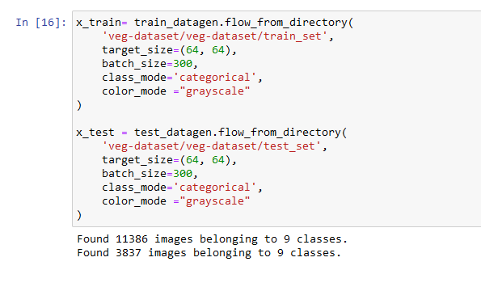
Resizing | 
Normalization | 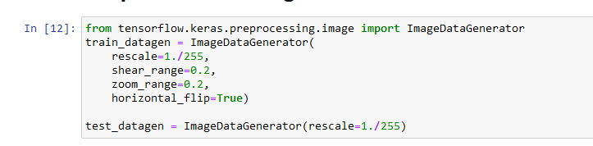
Data Augmentation | -
Denoising | -
Edge Detection | -
Color Space Conversion | -
Image Cropping | -
Batch Normalization | -

